Wasco

Resource Fair
Hosted by the Wasco Free Will Baptist CHurch
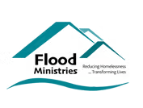  Providing mobile showers  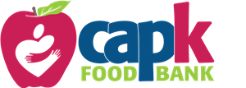  Providing hot food and snacks  (More services to be added) | Everyone is welcome  Open to the public @9am  2025 Dates:  January 18th, February 18th, March 18th, April 22nd, May 20th, and June 15th
938 7th Street, Wasco, Ca 93280
For more information call 661-758-5906

